Project 2

Pulling all assignment data information from the Assignment's Table, where the ProjectID is equal to 1400

SELECT \*

FROM 'assignment table'

WHERE ProjectID = 1400

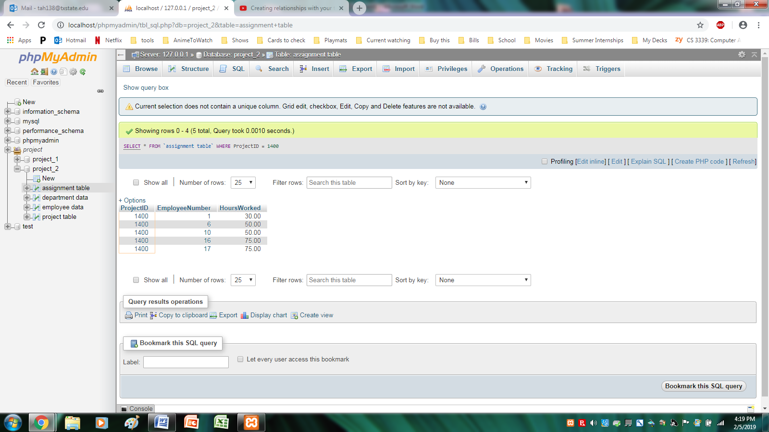

Pulled all project data from the Project Table, where the Project ID was not equal to 1400

SELECT \*

FROM 'project table'

WHERE ProjectID <> 1400

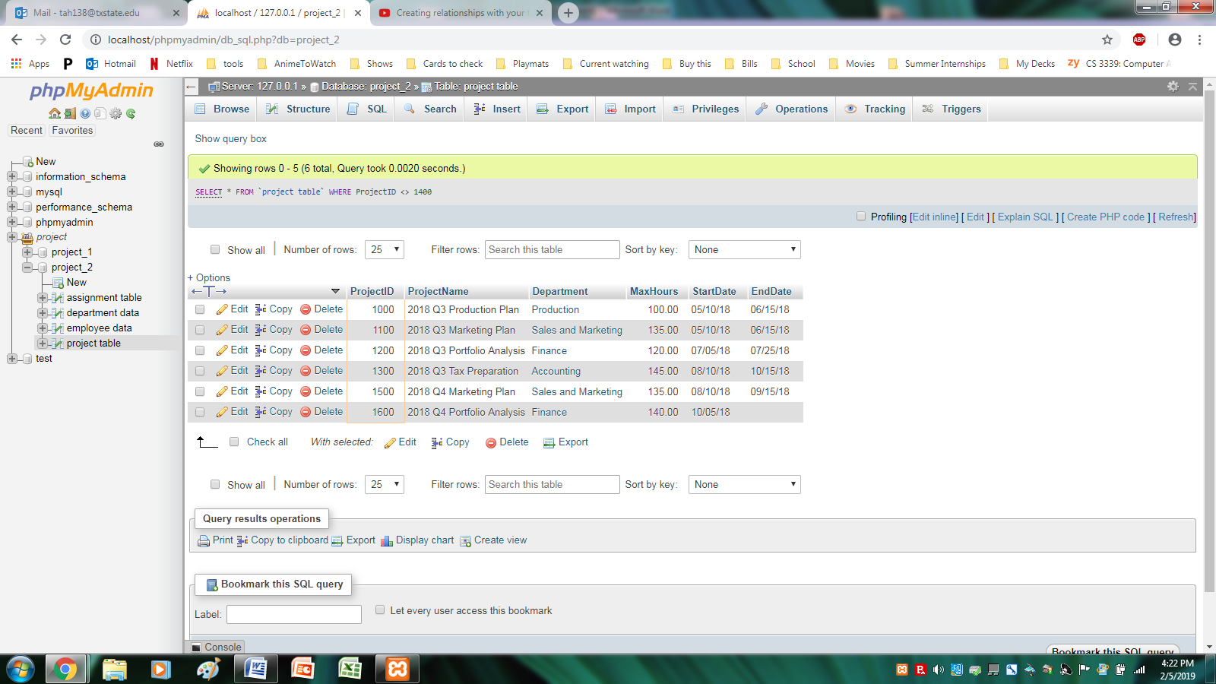

Selecting just the Project Name, Department it is from, and the Max Hours for the project, from the Project Table, and then Ordering it by the Max Hours.

SELECT ProjectName, Department, MaxHours

FROM 'project table'

ORDER BY MaxHours

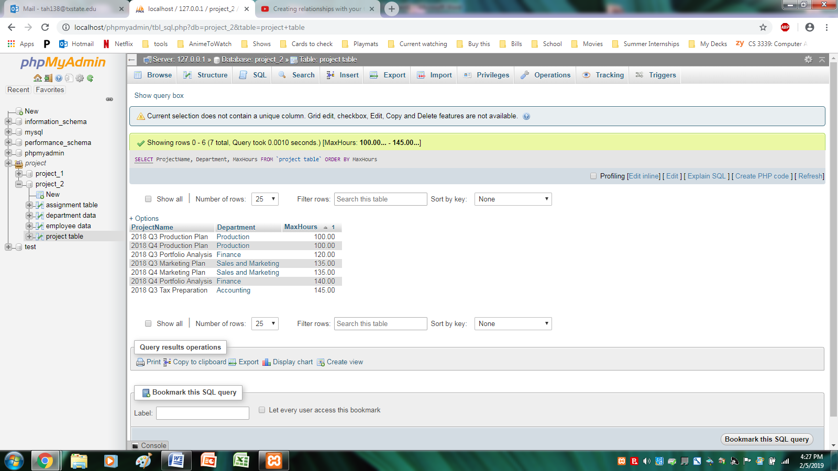

For the Assignment Table, I pulled all the information, and ordered it first by the Employee Number, and then by the ProjectID, so you can look at all the projects they worked on.

SELECT \*

FROM 'assignment table'

ORDER BY EmployeeNumber, ProjectID

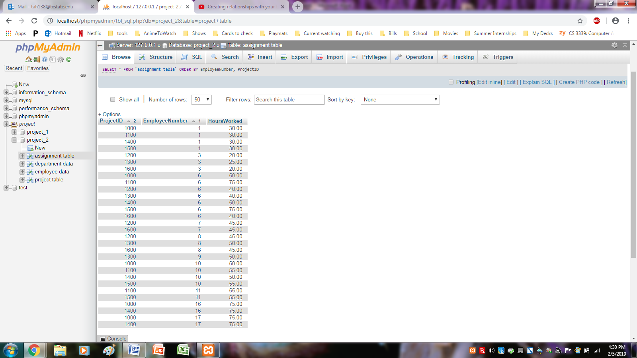

From the Assignment Table, I Summed up and grouped by Employee Number, the total number of hours that each employee worked.

SELECT EmployeeNumber, SUM(HoursWorked) AS TotalHoursworked

FROM 'assignment table'

GROUP BY EmployeeNumber

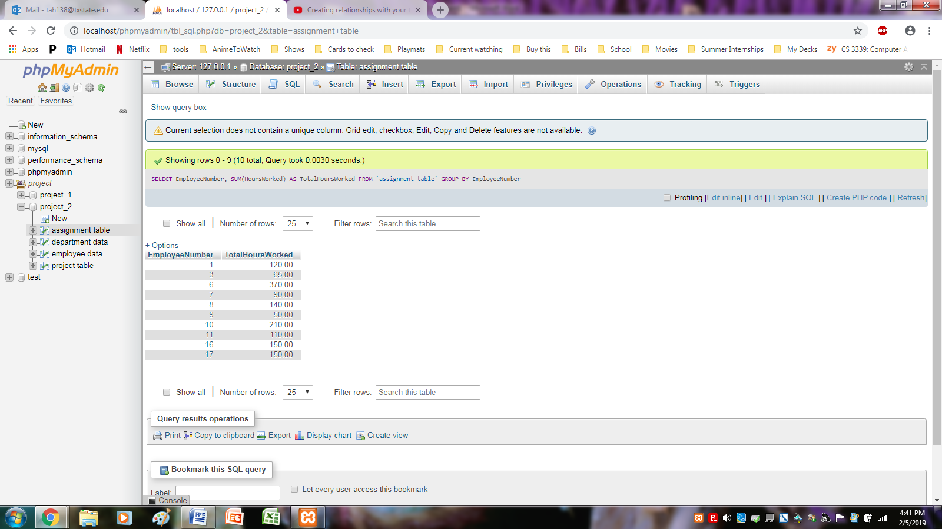

From Assignment Table, I had it count up the number of employees working on a given project, and display only the projects that have more than 4 people working on them

SELECT ProjectID, COUNT(EmployeeNumber) AS PeopleOnProject

FROM 'assignment table'

GROUP BY ProjectID

HAVING COUNT(EmployeeNumber) > 4

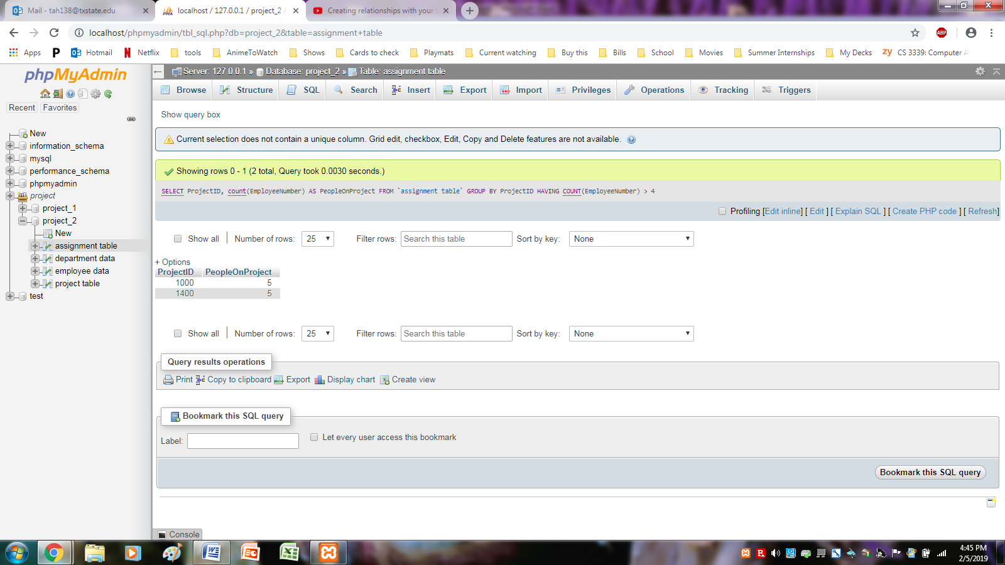

I pulled the information from Department Data, on the production department, Then output the names of the employees who all work in the production department.

SELECT FirstName, LastName

From 'employee data'

WHERE Department IN

(SELECT DepartmentName

FROM 'department data'

WHERE DepartmentName = 'Production')

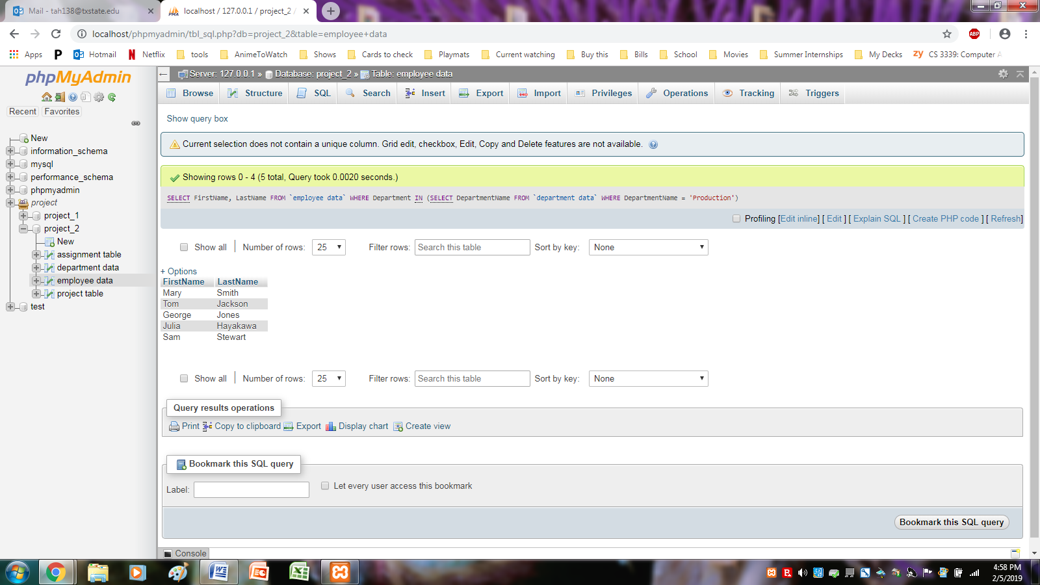

I pulled the number of departments that have a max hours over 120, and then from there I grouped up how many people worked in each of those departments, organizing it by the department. I also included the department number incase anything looked fishy.

SELECT Department, COUNT(Department) AS NumberOfPeopleThere, OfficePhone

FROM 'employee data'

WHERE Department IN

(SELECT department

FROM 'project table'

WHERE MaxHours > 120)

GROUP BY Department

ORDER BY Department

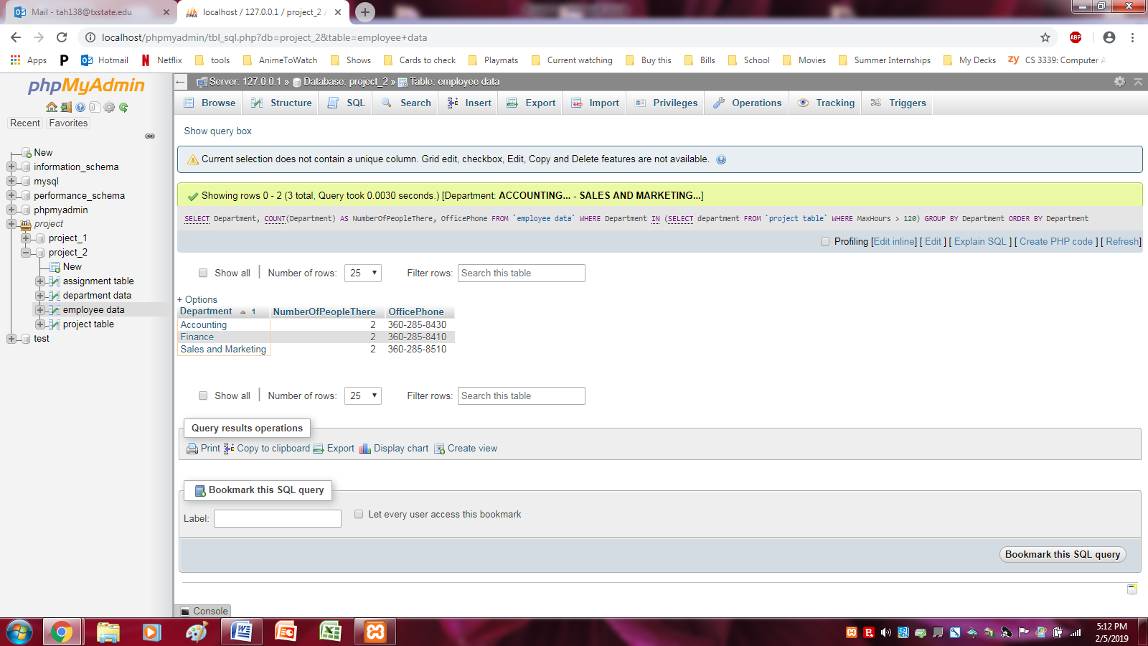

E/R Model

